Dynamic Programming --- Telescope Scheduling

**Telescope Scheduling**

Coin in a line

0/1 Knapsack

# 1. Telescope Scheduling

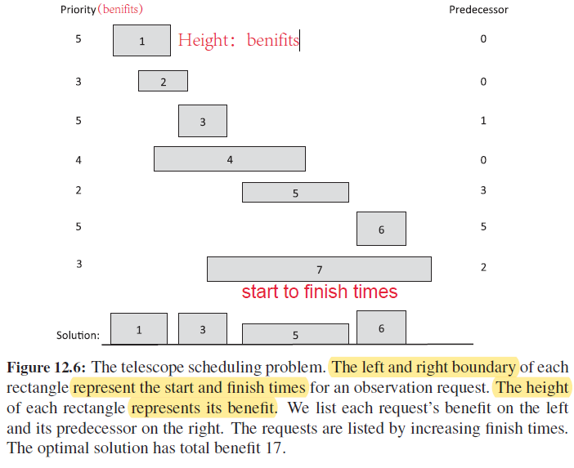

# 2. Explain the problem

Telescope Scheduling problem is that Given a list L, of observation requests, we need to schedule these observation requests **in a non-conflicting way** and **maximize the total benefit of the observations**.

si start time

fi finish time

bi benefit

pred(i) predecessor, to be the largest index, j<I, make request I and j don’t conflict. If no such index, return 0.

# 3. Algorithm

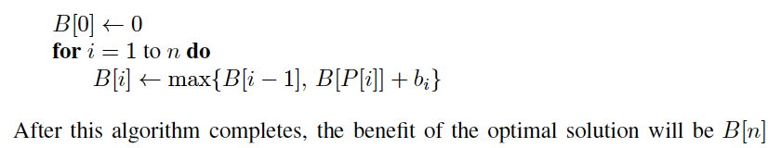

Runtime: O(n)

# 4. Explain the algorithm

Simple subproblem:

**Bi = the maximum benefit that can be achieved with the first i requests in L. So, as a boundary condition, we get that Bo = 0.**

Subproblem Optimality

The core to solve TS question is to make sure whether Bi should include observation i or not.

Case 1:

If including observation i, then B[i] = B[p[i]] + bi

B[p[i]] is the total maximum benefit without conflicting to i observation before.

Case 2:

If not including observation i, then B[i] = B[i-1]

We choose the greater value as Bi between Case 1 and Case 2.

Thus Bi = Max{B[i-1], B[p[i]] + bi}

Subproblem Overlap

**B[0] <- 0**

**for i <-1 to n do**

**B[i] = Max{B[i-1], B[p[i]] + bi}**

**Return B[n]**

Therefore, the maximum value of Task Scheduling problem is B[n].

# 5. Is it greedy or dynamic or some other type of algorithm, explain why?

False Start 1: Brute Force, take O(n*2^n) time,

False Start 2: Greedy Method

Proof by counter example:

